Helical Antenna

I. Normal Mode:
The Normal Mode pattern is the multiplication of element factor and array factor.
Far-zone electrical field is:
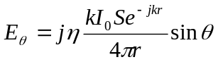 (10-25)
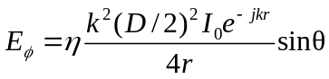 (10-26)
Far-zone radiation intensity is:
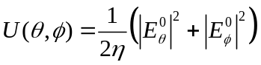 (12-13)
Normalized form is reduced to:
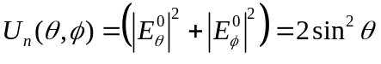 (12-14)
Therefore, the normalized element factor is:
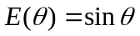
The array factor is given by (6-10c):
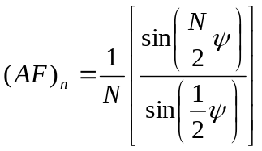 (6-10c)
where 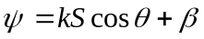, where the phase difference 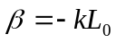. In the program, we assume the phase difference is β = 0. Thus the power pattern is:
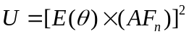
The Pitch angle, Axial ratio are given by (10-24) and (10-27), respectively; The Directivity is calculated by 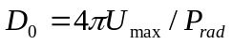 from the radiation pattern.

II. Axial Mode:

The radiation pattern is given by (10-35) to (10-35c).
The Input impedance, HPBW, FNBW, Relative phase velocity ratio and Directivity are given by (10-30), (10-31), (10-32), (10-35b), (10-35c) and (10-33), respectively.

